12. ReactJS-HOL

**Solution:**

Step **1:** Creating a React-App named “**ticketbookingapp**” using the command:

[**npx create-react-app ticketbookingapp**]

Step **2: Creating Component Files** inside a folder named “components”:

1. 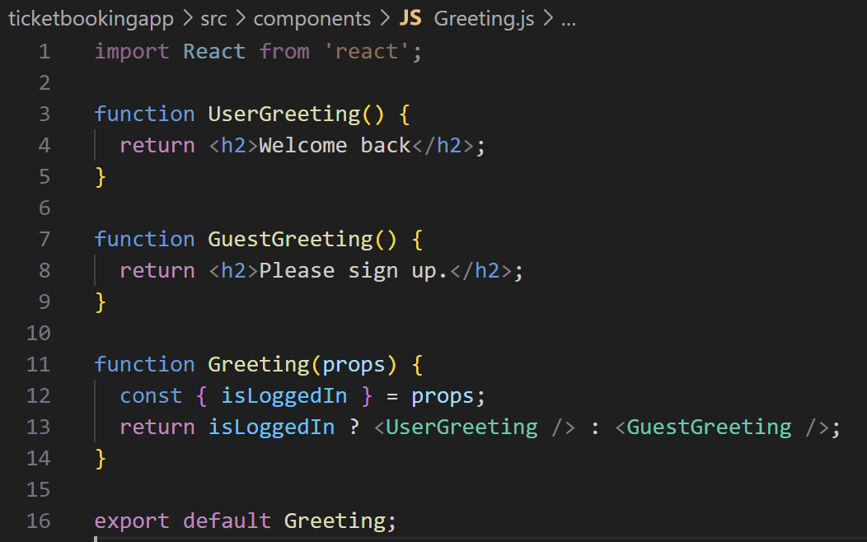**Greeting.js:** Displays a message based on login status.
2. **LoginButton.js:** A simple button component that triggers **onClick** passed from parent to log in.

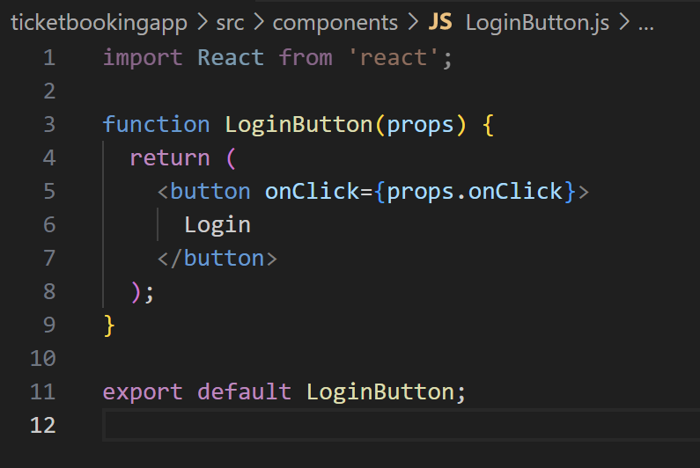

1. 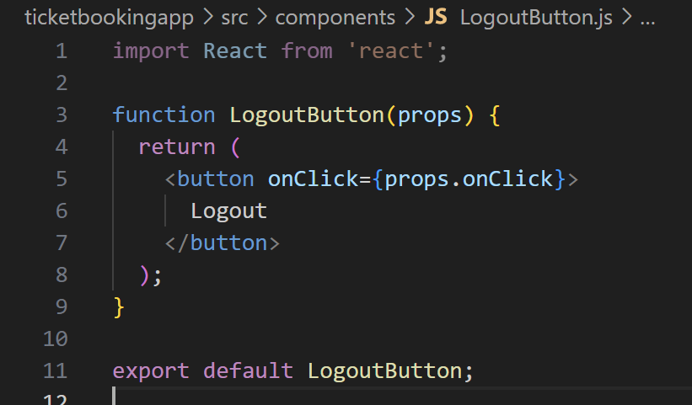**LogoutButton.js:** Similar to LoginButton but handles logout.

Step **3:** Modifying **App.js** to render in the final page

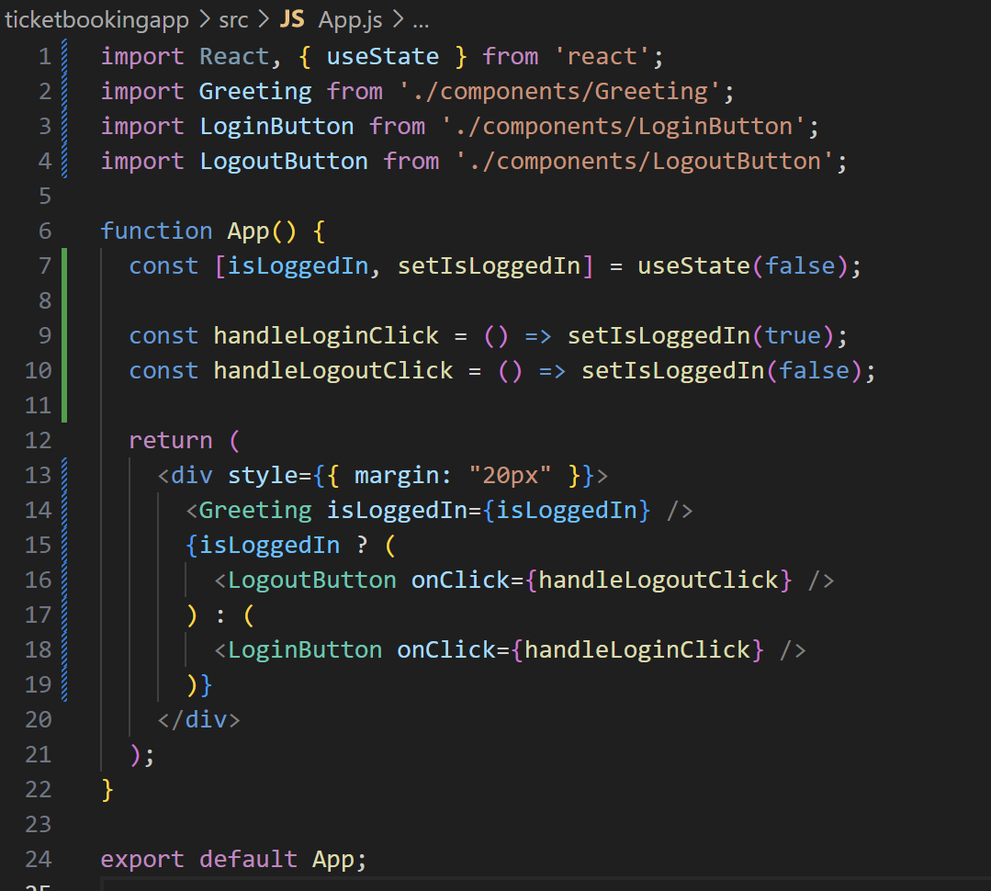

Step **4: Run** the application --. **npm start**

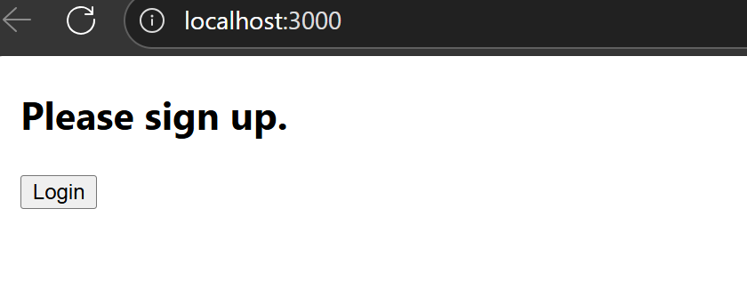

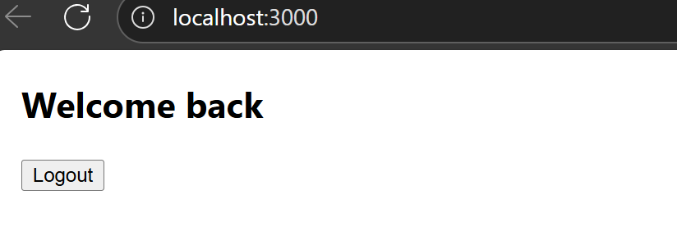

**Working of the above app:**

* Initial View:
  + Message: *“Please sign up.”*
  + Button: **Login**
* After Clicking **Login**:
  + Message: *“Welcome back”*
  + Button: **Logout**
* After Clicking **Logout**, it switches back to initial-view.

************************************************************************************